EXERCISE – 04 (POLYNOMIAL REGRESSION)
1. AIM
To implement degree-2 Polynomial Regression to predict the weight of a fish from its measurements, evaluate the predictions with regression metrics, and visualize the fitted curve.
2. ALGORITHM
1. Load and inspect the fish dataset.
2. Encode the Species column using one-hot encoding.
3. Separate Weight as the target variable and the remaining columns as predictors.
4. Split the data into training and testing sets in an 80:20 ratio with random_state = 42.
5. Generate degree-2 polynomial features using PolynomialFeatures.
6. Train a Linear Regression model on the transformed features and predict the test set.
7. Calculate MAE, MSE, RMSE, R², MAPE, Explained Variance and Maximum Error.
8. Plot the polynomial relationship between Length3 and Weight.
3. PROGRAM
import pandas as pd
import numpy as np
import matplotlib.pyplot as plt
from sklearn.model_selection import train_test_split
from sklearn.preprocessing import PolynomialFeatures
from sklearn.linear_model import LinearRegression
from sklearn.metrics import (
mean_absolute_error,
mean_squared_error,
r2_score,
mean_absolute_percentage_error,
explained_variance_score,
max_error
)
data = 'Dataset/fish.csv'
df = pd.read_csv(data)
df.head()
df.info()
df.shape
df = pd.get_dummies(df, columns=['Species'], drop_first=True)
X = df.drop("Weight", axis=1)
y = df["Weight"]
x1, x2, y_train, y_test = train_test_split(
X,
y,
test_size=0.2,
random_state=42
)
poly = PolynomialFeatures(degree=2)
X_train_poly = poly.fit_transform(x1)
X_test_poly = poly.transform(x2)
model = LinearRegression()
model.fit(X_train_poly, y_train)
# Prediction
y_pred = model.predict(X_test_poly)
mae = mean_absolute_error(y_test, y_pred)
mse = mean_squared_error(y_test, y_pred)
rmse = np.sqrt(mse)
r2 = r2_score(y_test, y_pred)
mape = mean_absolute_percentage_error(y_test, y_pred)
evs = explained_variance_score(y_test, y_pred)
maxerr = max_error(y_test, y_pred)
# Adjusted R²
n = X_test_poly.shape[0]
p = X_test_poly.shape[1] - 1
adj_r2 = 1 - ((1-r2)*(n-1)/(n-p-1))
print("\n========== Evaluation Metrics ==========")
print("MAE :", mae)
print("MSE :", mse)
print("RMSE :", rmse)
print("R2 Score :", r2)
print("Adjusted R2 :", adj_r2)
print("MAPE :", mape)
print("Explained Variance :", evs)
print("Maximum Error :", maxerr)
X = df[['Length3']]
y = df['Weight']
poly = PolynomialFeatures(degree=2)
X_poly = poly.fit_transform(X)
model = LinearRegression()
model.fit(X_poly, y)
X_grid = np.arange(
X.min().values[0],
X.max().values[0],
0.1
).reshape(-1,1)
plt.figure(figsize=(8,6))
plt.scatter(X, y, color="blue", label="Actual Data")
plt.plot(
X_grid,
model.predict(poly.transform(X_grid)),
color="red",
linewidth=3,
label="Polynomial Curve"
)
plt.xlabel("Length3")
plt.ylabel("Weight")
plt.title("Polynomial Regression")
plt.legend()
plt.show()

4. OUTPUT
The program was executed on the Fish dataset (fish.csv) and produced the following output:
Species Weight Length1 Length2 Length3 Height Width
0 Bream 242.0 23.2 25.4 30.0 11.5200 4.0200
1 Bream 290.0 24.0 26.3 31.2 12.4800 4.3056
2 Bream 340.0 23.9 26.5 31.1 12.3778 4.6961
3 Bream 363.0 26.3 29.0 33.5 12.7300 4.4555
4 Bream 430.0 26.5 29.0 34.0 12.4440 5.1340
<class 'pandas.core.frame.DataFrame'>
RangeIndex: 159 entries, 0 to 158
Data columns (total 7 columns):
# Column Non-Null Count Dtype
--- ------ -------------- -----
0 Species 159 non-null object
1 Weight 159 non-null float64
2 Length1 159 non-null float64
3 Length2 159 non-null float64
4 Length3 159 non-null float64
5 Height 159 non-null float64
6 Width 159 non-null float64
dtypes: float64(6), str(1)
memory usage: 8.8 KB
(159, 7)
========== Evaluation Metrics ==========
MAE : 48.409823644028464
MSE : 5620.7129176326325
RMSE : 74.97141400315611
R2 Score : 0.9604841036350548
Adjusted R2 : 1.0266302779850718
MAPE : 0.24553055496984066
Explained Variance : 0.9618750799874711
Maximum Error : 266.19008812732295
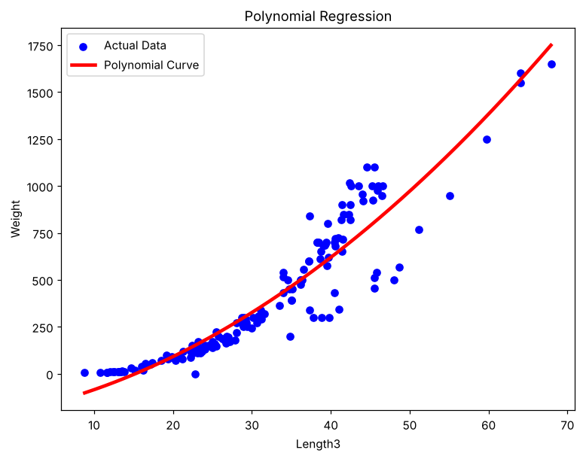

5. RESULT
Thus, the Polynomial Regression practical was implemented successfully. The degree-2 model achieved an R² score of 0.9605, an MAE of 48.41 and an RMSE of 74.97 on the test set, showing that the curved relationship between the fish measurements and weight is captured well.

